**Professional Readiness for**

**Innovation, Employability and Entrepreneurship**

ASSIGNMENT 1

SMART HOME

Submitted by,

Nivedha M S

Reg No. 961819106040

Batch:- B12-6A2E

SMART HOME

CODE FOR SMART HOME:-

#include <Servo.h>

int location = 0;

int i = 0;

int j = 0;

Servo s;

void setup()

{

Serial.begin(9600);

pinMode(4,INPUT);//PIR sensor

pinMode(13,OUTPUT);//Red LED inside home

pinMode(12,OUTPUT);//Buzzer for temp

s.attach(10, 500, 2500);//micro servo

pinMode(3,INPUT); //ECHO in ultrasonic

pinMode(2,OUTPUT); //TRIGGER in ultrasonic

}

void loop()

{

int n=digitalRead(4);

Serial.println(n);

if(n){

Serial.println("MOTION DETECTED!!!");

location = 0;

for (location = 1; location <=180; location+=60){

s.write(location);

delay(100);

double a=analogRead(A0);

double t=(((a/1024)*5)-0.5)*100;

Serial.print("TEMP VALUE: ");

Serial.println(t);

if (t>100){

for(int j=200;j<220;j++)

{

tone(12,j);

}

delay(1000);

noTone(12);

}

digitalWrite(2,LOW);

digitalWrite(2,HIGH);

delay(1000);

digitalWrite(2,LOW);

float dur=pulseIn(3,HIGH);

float dis=(dur*0.0343)/2;

digitalWrite(13,LOW);

if (dis<20){

Serial.print("Distance: ");

Serial.print(dis);

Serial.println(" cm");

digitalWrite(13,HIGH);

}

}

digitalWrite(2,LOW);

digitalWrite(2,HIGH);

delay(1000);

digitalWrite(2,LOW);

float dur=pulseIn(3,HIGH);

float dis=(dur*0.0343)/2;

digitalWrite(13,LOW);

if (dis<20){

Serial.print("Distance: ");

Serial.print(dis);

Serial.println(" cm");

digitalWrite(13,HIGH);

}

}

delay(1000);

}

CIRCUIT DIAGRAM FOR SMART HOME:-

Tinker cad link: <https://www.tinkercad.com/things/dtgmJXNtlb8-smart-home>

SNAPS OF SMART HOME:-

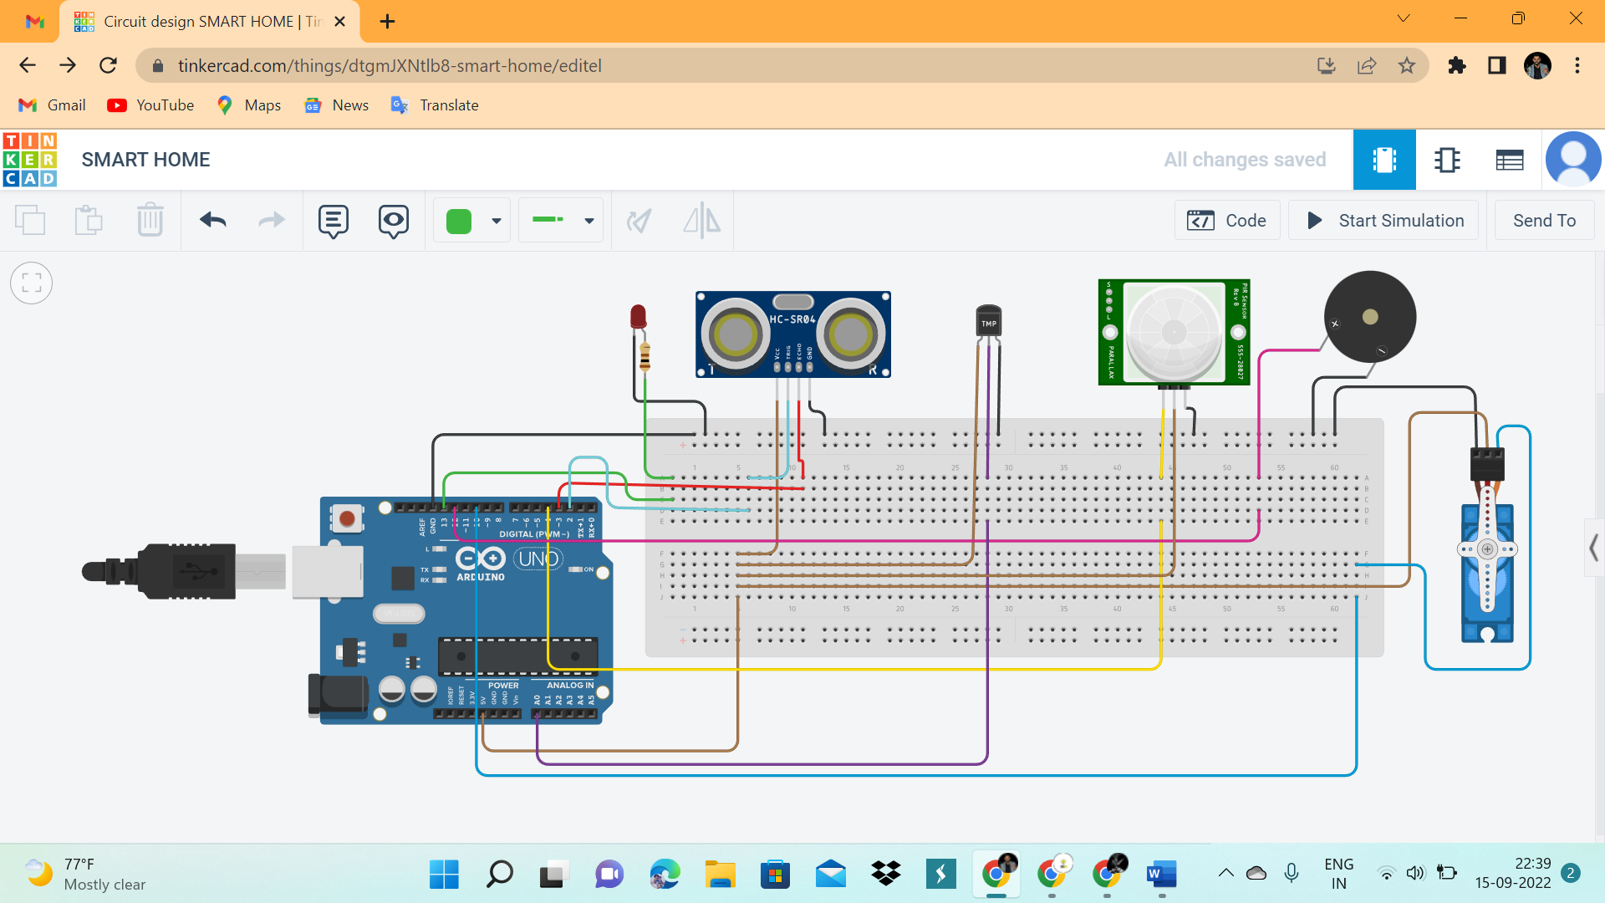

Fig. Smart Home Circuit

The above diagram shows the smart home application in which MICRO SERVO (Pin:10) act as the door of the room and the door is fitted with the PIR SENSOR(Pin:4-DigitalRead) to detect the motion. When motion of a user is detected by the PIR, the door (micro servo) starts opening at the same time, the temperature is detected using TEMEPERATURE SENSOR (Pin: A0). If the temperature is more than 100, then the buzzer starts to beep till the temperature is reduced than 100. The ULTRASONIC SENSOR (Pin: Tri-2-DigitalWrite; Ech-3-DigitalRead) which help to detect the distance is connected near the LED(Pin:13-DigitalWrite) light. So, when the user comes close to the ultrasonic sensor in a particular distance, the light in the particular area starts glowing.

If smart homes were developed then the power consumption will be less and so resources may have long life time and cost paid for electricity is less as well as maintenance required is very less compared with others.